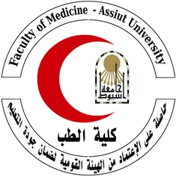

***Curriculum Vitae***

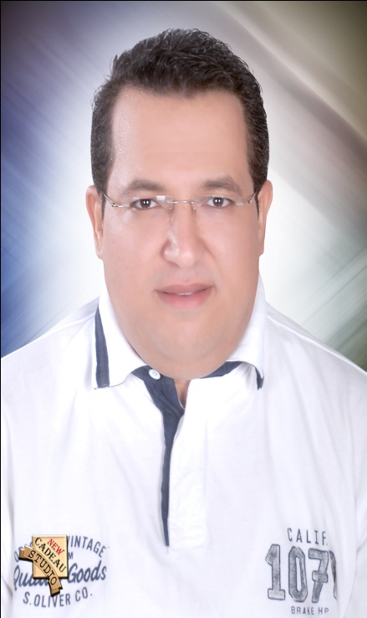

**Personal information:**

**Name**: Mohamed Ismaeil Seddik Mohamed.

**Gender:** Male.

**Date of birth:** April /7/1981.

**Citizenship:** Egyptian.

**Marital status:** Married.

**Last Degree:** M.D. in clinical pathology.

**E-mail address:** moh_ismail310@yahoo.com.

**Address:** Egypt, Assiut, 34 Mahmoud Rashwan str.

**Telephone Cellular:** 002-0100-6578850.

**Work:** 002-088-2413394.

**Fax:** 002-088- 2342708.

**Languages:**

**Arabic:** Mother language.

**English:** Local toefl test with score 527 in february 2013.

**Education and Training:**

**FORMAL EDUCATION**

▪ **1987-1992 :** Primary School.

▪ **1992-1995 :** Preparatory School.

▪ **1995-1998 :** Secondary School.

**GRADUATION**

▪ **January 2005:** MBBCH; Faculty of Medicine, Assiut University, Assiut, Egypt; Very Good With Honor.

**Works:**

* House 0fficer doctor in Assiut University Hospital, Assiut, Egypt : **March 2005 – February 2006.**
* Resident doctor in Clinical Pathology Department, Assiut University Hospital, Egypt : **March 2006 - February 2009.**
* Demonstrator in Clinical Pathology Department, Assiut University Hospital, Egypt : **February 2009 – March 2010.**
* Assistant lecturer in Clinical Pathology Department, Assiut University Hospital, Egypt : **March 2009 - December 2013.**
* Lecturer in Clinical Pathology Department, Assiut University Hospital, Egypt: **March 2014 - to date.**

**Qualifications:**

* Degree of Bachelor of Medicine and Surgery **(M.B.B.CH) 2004**, Faculty of Medicine, Assiout University, Egypt.
* Master Degree of Clinical pathology **(M.Sc) 2009,** Faculty of Medicine, Assiout University, Egypt.

The Title of the M.Sc. thesis :

**“Recent Laboratory Diagnosis of Lipid Storage diseases” (2009)**, M.Sc. Thesis, Department of Clinical Pathology, Faculty of Medicine, Assiut University, Egypt.

* Doctor Degree of Clinical pathology **(M.D) 2013,** of Medicine, Assiout University, Egypt.
* The Title of the M.D. thesis :

**“Diagnostic Values Of Gene Expression Of Cytokeratin – 19 mRNA and Mammaglobin mRNA In Breast Cancer Patients Using Real-Time Polymerase Chain Reaction” (2013)**, M.D. Thesis, Department of Clinical Pathology, Faculty of Medicine, Assiut University, Egypt.

**Publications :**

“DIAGNOSTIC VALUES OF GENE EXPRESSION OF CYTOKERATIN – 19 mRNA AND MAMMAGLOBIN mRNA IN BREAST CANCER PATIENTS USING REAL-TIME POLYMERASE CHAIN REACTION”

Osama B. S. Osman, Mohamed S. M. Khalil, Tahra M. K. Sherif, Hanan O. Mohamed, Hesham M. Hamza, Mohamed I. Sedik. Department of Clinical Pathology, Faculty of Medicine, Assiut University and South Egypt Cancer Institute, Assiut University. Assiut Med. J. Vol. (38), No. (1), January 2014.

**Conferences and workshops :**

* The Annual scientific Conference “ Quality Control & Quality assurance in Scientific Research” , Faculty of Medicine, Assiout University, 17-19 March 2008.
* “The Power of Real Time- polymerase Chain Reaction (RT-PCR)” Workshop, Dept. of Biology, Faculty of Science, Assiout University, 23-25 April 2010.
* “PCR” Workshop, Dept. of Biology, Faculty of Science, Assiout University, 14-16 November 2011.
* “Alternative Medicine” Conference, Faculty of Medicine, Assiout University, 4-6 March 2012.
* “Academic Accreditation” Workshop, Faculty of Medicine, Assiout University, 1-3 October 2012.
* “Chemicals: Advantages& Disadvantages” Workshop, 2013, Faculty of Medicine, Assiout University.
* The Annual scientific Conference “Up-todate in laboratory Medicine” , Faculty of Medicine, Assiout University, 20-22 March 2014.

**Research Interests :**

After finishing my M.D. thesis, I plan to continue my scientific career in the field of molecular biology and to deepen my understanding of the molecular mechanisms of cancer progress, recurrence, and metastasis.

Currently, I am looking forward for a research project that deals with new methods and new markers used for diagnosis of circulating tumor cells, early diagnosis of metastasis.

I am a hard-working and determined person and i am ready for a new leap in my career. I will work hard in hope that the quantity of the effort I put in will result in high quality knowledge.

**Teaching Experience:**

* Demonstrator in Clinical Pathology Department, Assiut University Hospital, Egypt : **February 2009 – March 2010.**
* Assistant lecturer in Clinical Pathology Department, Assiut University Hospital, Egypt : **March 2009 - December 2013.**
* Lecturer in Clinical Pathology Department, Assiut University Hospital, Egypt: **March 2014 - to date.**

**Membership of Scientific Societies :**

* Egyptian Society of Clinical Pathology.

**Training Programs:**

* Effective communication skills (March 2010).
* Legal aspects of universities (May 2010).
* Thinking skills (June 2010).
* Effective presentation skills (June 2010).
* Exams systems and student assessment (Feb. 2011)
* The use of technology in teaching (March 2011).
* Systems of credit hours (April 2011).
* Research team management (March 2013).
* Student assessment in medical education (March 2014).
* Teaching methods in medical education (September 2014).

**Computer Skills:**

Excellent general computer skills (International Computer Driving License).

**Awards:**

* **2005:** Certificate of honor and Assiut University Medal from Faculty of Medicine, Assiut univesity for MBBCH.
* **2009:** Certificate of honor and the University symbol Award from Assiut univesity for M.Sc. degree.
* **2009:** Certificate of honor and medal of Assiut univesity for appointed as a demonstrator in the faculty of Medicine.
* **2013:** Certificate of honor and the University symbol Award from Assiut univesity for M.D. degree.

**Activities:**

* Reading.
* Music and songs listening.
* Computer and Internet.
* Traveling.